Buffer Management performance improvement

Scenario:
- 50% of buffers (same buffers) are used for very frequent operation as executing same queries in regular intervals (500 ms).
- 50% reaming buffers are used for loading random pages

For case -1: As hit ratio is high no pages required to be loaded. (mostly all pages will have usage count with more than 1 so pages will not be replaced)

Simulation Test setup:

1. Database size: 1 GB, shared buffers: 500 MB

2. Create the schema using pgbench
./pgbench -i -s 150 -d postgres

3. Load all the files in to OS buffers; for this we are using pg_prewarm tool as follows
select pg_prewarm('pgbench_accounts', 'main', 'prefetch', NULL, NULL);
select pg_prewarm('pgbench_branches', 'main', 'prefetch', NULL, NULL);
select pg_prewarm('pgbench_tellers', 'main', 'prefetch', NULL, NULL);
select pg_prewarm('pgbench_accounts_pkey', 'main', 'prefetch', NULL, NULL);
select pg_prewarm('pgbench_branches_pkey', 'main', 'prefetch', NULL, NULL);
select pg_prewarm('pgbench_tellers_pkey', 'main', 'prefetch', NULL, NULL);

4. Load the random tables buffers once [ pgbench tables ]
select pg_prewarm('pgbench_accounts', 'main', 'buffer', NULL, NULL);
select pg_prewarm('pgbench_branches', 'main', 'buffer', NULL, NULL);
select pg_prewarm('pgbench_tellers', 'main', 'buffer', NULL, NULL);
select pg_prewarm('pgbench_accounts_pkey', 'main', 'buffer', NULL, NULL);
select pg_prewarm('pgbench_branches_pkey', 'main', 'buffer', NULL, NULL);
select pg_prewarm('pgbench_tellers_pkey', 'main', 'buffer', NULL, NULL);

5. Create a exclusive set table having number of pages 31000. (this for simulating the 50% buffers) which will be executed in interval of 500 millisec
select pg_prewarm('othertbl', 'main', 'buffer', 0, 31000);
select pg_prewarm('othertbl', 'main', 'buffer', 0, 31000);
select pg_prewarm('othertbl', 'main', 'buffer', 0, 31000);
select pg_prewarm('othertbl', 'main', 'buffer', 0, 31000);
select pg_prewarm('othertbl', 'main', 'buffer', 0, 31000);
RUN the test as follows:
- Run the pgbench with select only , 8 – threads, 8 connections for 10 minutes
- One more parallel psql connection with pgbench which will run every 500 milli seconds runs one following sql query
“select pg_prewarm('othertbl', 'main', 'buffer', 0, 31000);”

VTUNE Results:

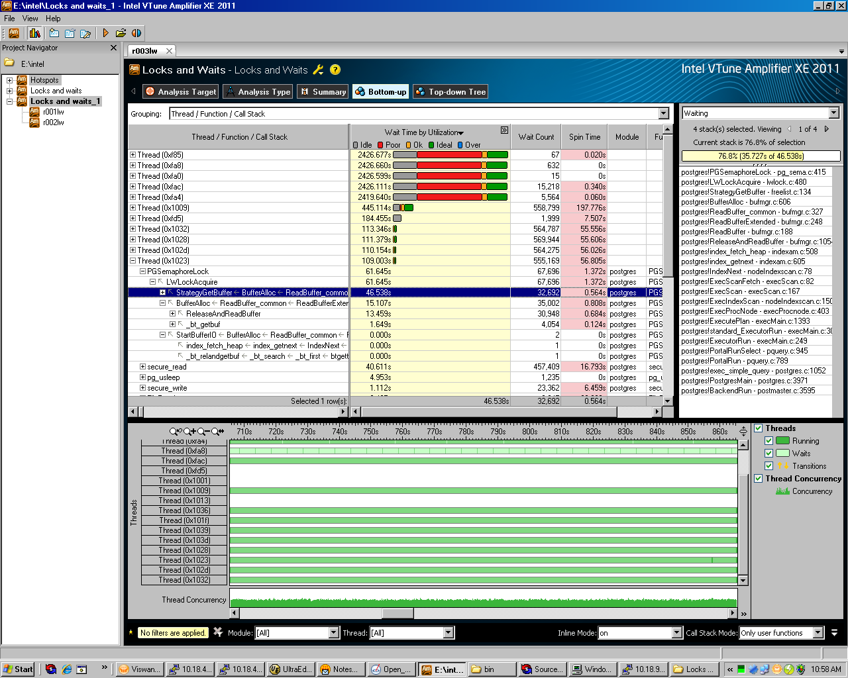

Observations:
- Backend threads (pgbench client session), consider a thread id 0x1023 is wait on FreeListLock for 46.83 sec out of 109.003 sec complete thread wait time.
- And also waiting on Heap partition lock for 15.107sec.

